GIT TASK -02

- Install git.
Steps
Step 1: Download Git from the official Git website.
Download Git for Windows
Step 2: Install Git using the default installation options.
Step 3: Open Git Bash.
Step 4: Check the installed Git version.
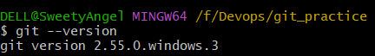

- Create a repo in github with README.md and .ignore file.
Steps
Step 1: Log in to GitHub.
Step 2: Click New Repository.
Step 3: Enter the repository name.
Example:
git-practice
Step 4: Select:
Step 5: Click Create repository.
The repository will contain:
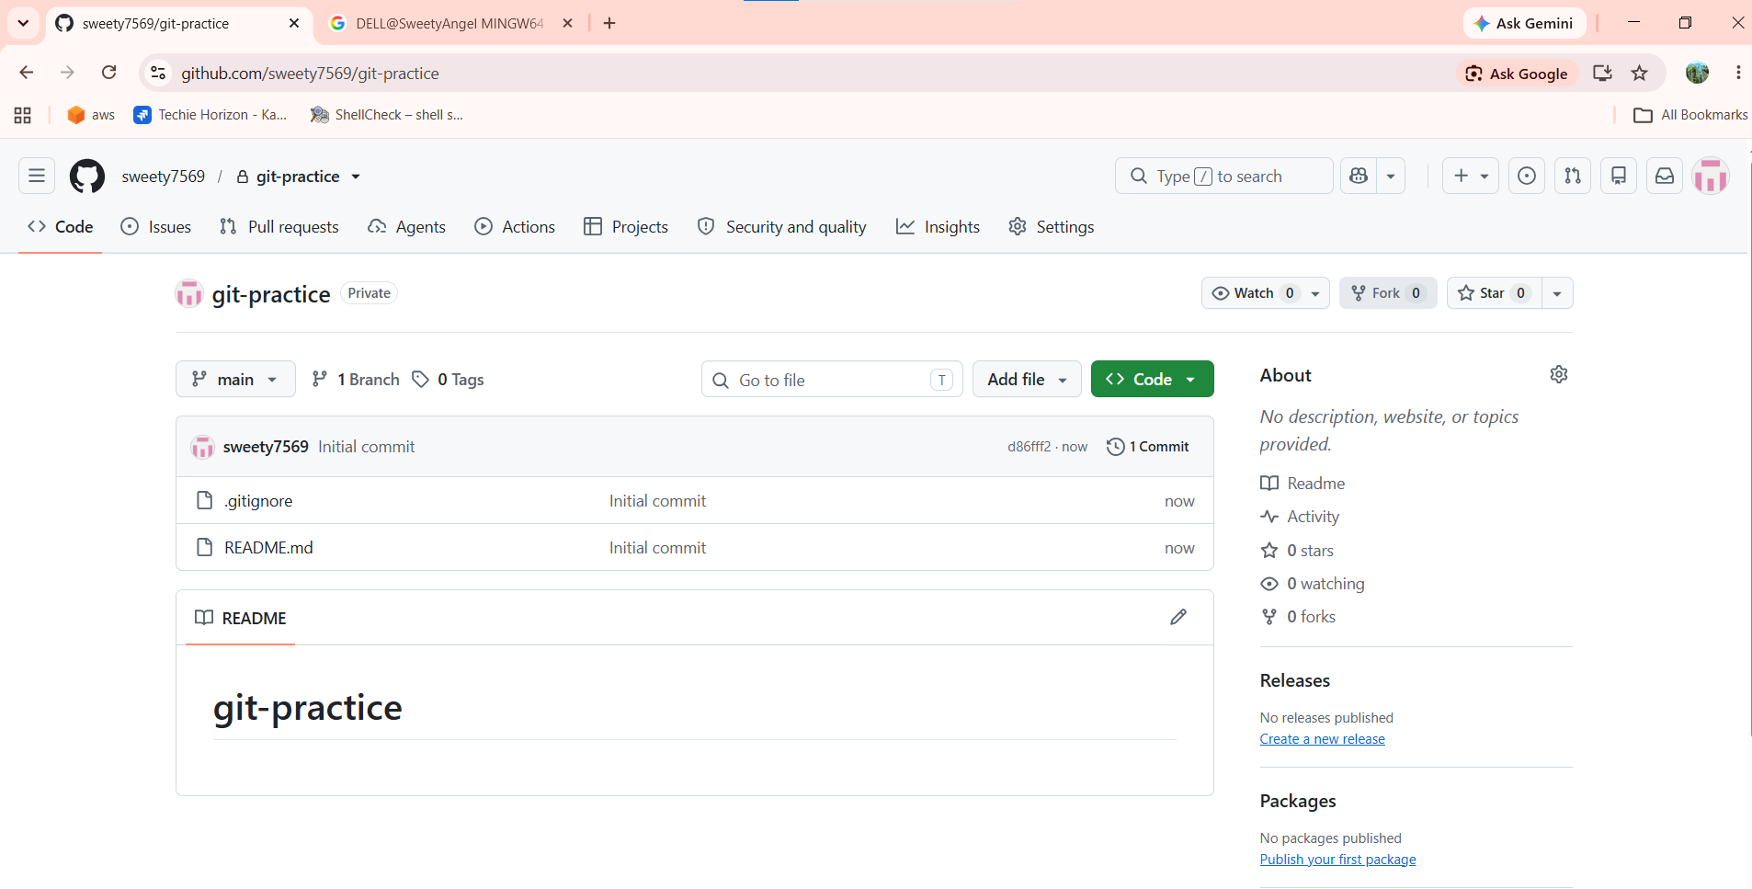

- Clone the created repo to local.
Objective
To download the GitHub repository to the local computer.
Steps
Step 1: Open Git Bash.
Step 2: Navigate to the directory where you want to store the repository.
cd /f/Devops
Step 3: Clone the GitHub repository.
Using HTTPS:
git clone https://github.com/USERNAME/git-practice.git
Or using SSH:
git clone git@github.com:USERNAME/git-practice.git
For example:
git clone git@github.com:sweety7569/git-practice.git
Step 4: Enter the repository.
cd git-practice
Step 5: Check the files.
ls
Step 6: Check Git status.
git status
Step 7: Check the remote repository.
git remote -v
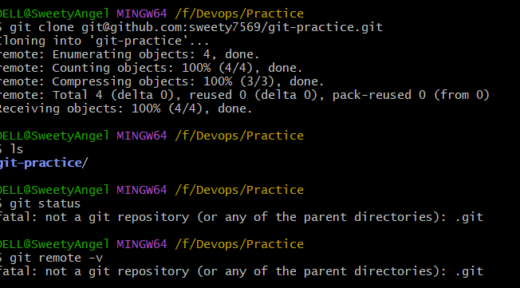

- Create two files in local repo.
Objective
To create two files inside the local Git repository.
Steps
Step 1: Make sure you are inside the repository.
cd /f/Devops/git-practice
Step 2: Create the first file.
echo "This is file 1" > file1.txt
Step 3: Create the second file.
echo "This is file 2" > file2.txt
Step 4: Check the files.
ls
Step 5: Check Git status.
git status
The files should appear as untracked files.
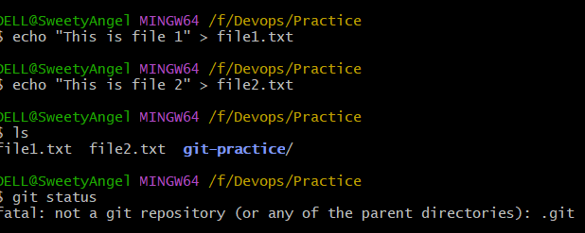

- Commit two files and push to central Repository.
Objective
To add, commit, and push two local files to GitHub.
Steps
Step 1: Add the files to the staging area.
git add file1.txt file2.txt
Step 2: Check the status.
git status
The files should appear under:
Changes to be committed
Step 3: Commit the files.
git commit -m "Added two files"
Step 4: Push the commit to GitHub.
If your branch is main:
git push origin main
If your branch is master:
git push origin master
Step 5: Open GitHub and refresh the repository.
The files should now be visible.
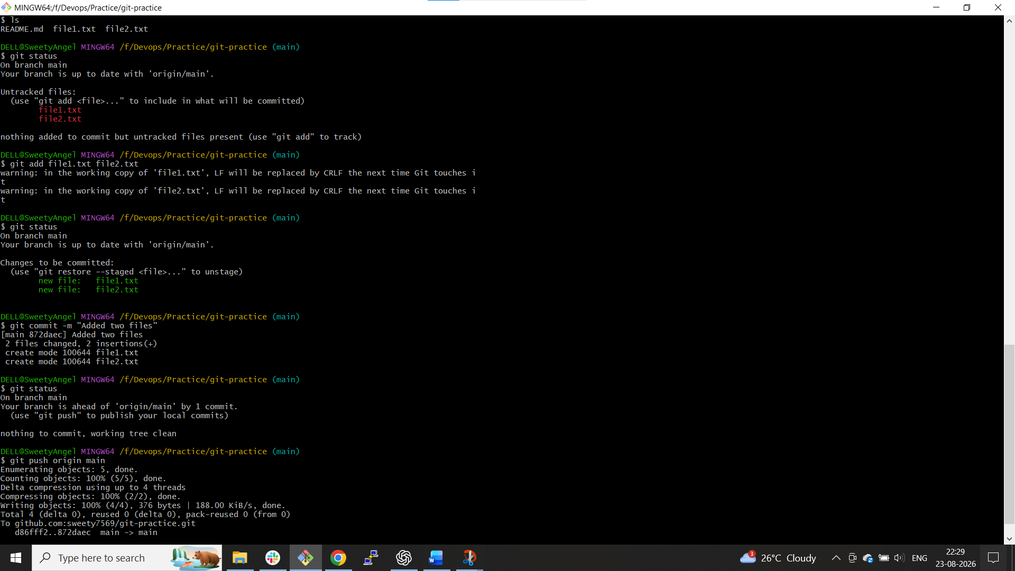
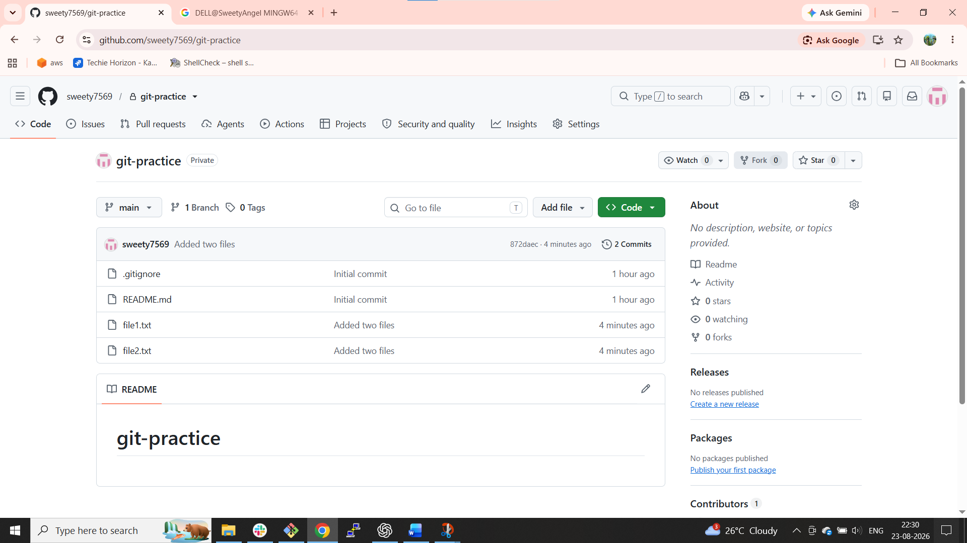

- Create a branch in local and create a sample file and push to central.
Create a branch:
git branch feature
Switch to it:
git switch feature
Or in one command:
git switch -c feature
Create a file:
echo "This is a feature file" > feature.txt
Add:
git add feature.txt
Commit:
git commit -m "Added feature file"
Push the branch to GitHub:
git push -u origin feature
Now go to GitHub → Branches.
You should see:
main
feature
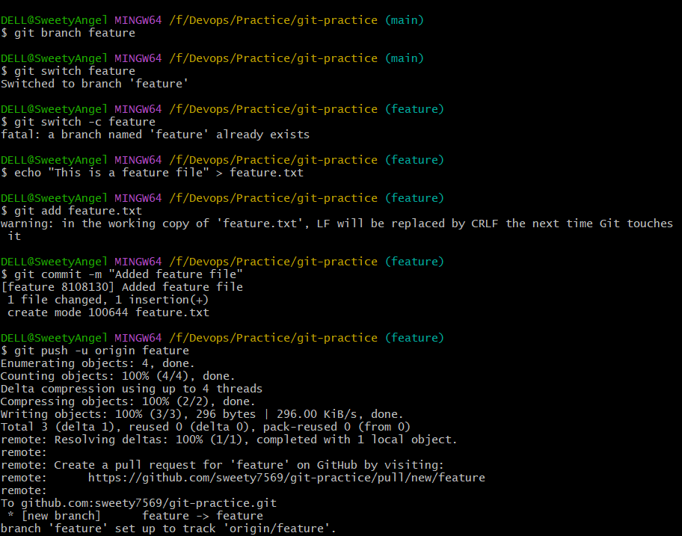

- Create a branch in github and clone that to local.
Go to GitHub.
Repository → Branches → create a new branch.
For example:
github-feature
Now fetch the remote branches:
git fetch origin
Check branches:
git branch -a
You should see something like:
* feature
main
remotes/origin/feature
remotes/origin/github-feature
Create a local branch tracking the GitHub branch:
git switch -c github-feature --track origin/github-feature
Check:
git branch
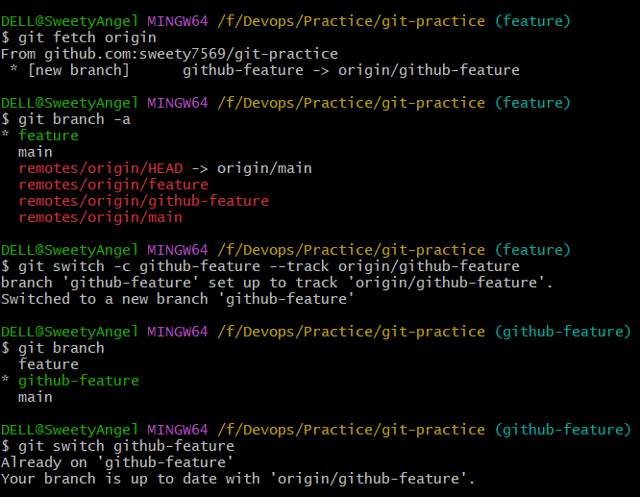

- Merge the created branch with master in git local.
First switch to your main/master branch.
If your branch is main:
git switch main
If it is master:
git switch master
Pull the latest changes:
git pull origin main
Merge your feature branch:
git merge feature
If there are no conflicts, you'll see a successful merge.
Push the merged result:
git push origin main
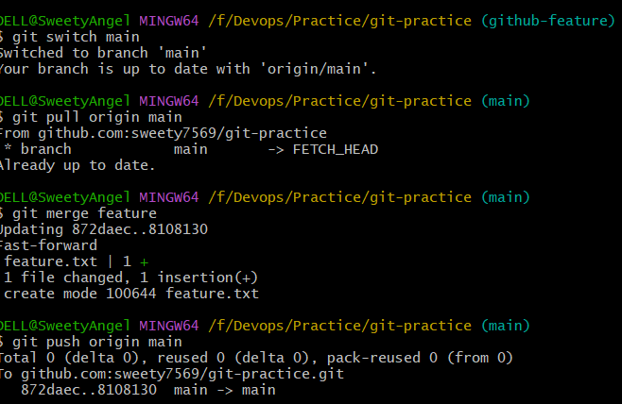

- Merge the created branch with master in github by sending a pull request.
This is the GitHub Pull Request workflow.
You already pushed:
feature
to GitHub.
Go to:
GitHub → Repository → Pull requests → New pull request
Select:
base: main
compare: feature
Click:
Create pull request
Then:
Merge pull request → Confirm merge
After merging, your feature branch changes are now in main.
Locally, update your repository:
git switch main
git pull origin main
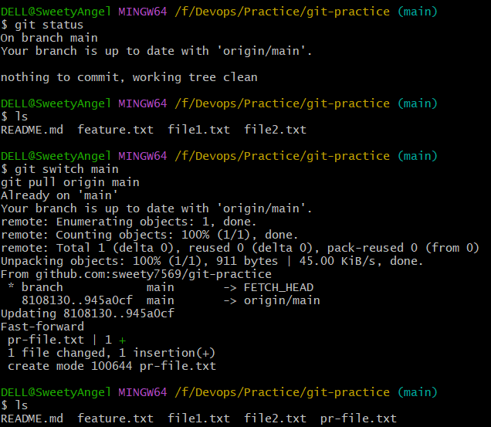
- Create a file in local and send that to branch in github.
Suppose you want to send the file to feature.
Switch to the branch:
git switch feature
Create the file:
echo "This file belongs to feature branch" > branchfile.txt
Add:
git add branchfile.txt
Commit:
git commit -m "Added branch file"
Push:
git push origin feature
Now the file will appear in the feature branch on GitHub.
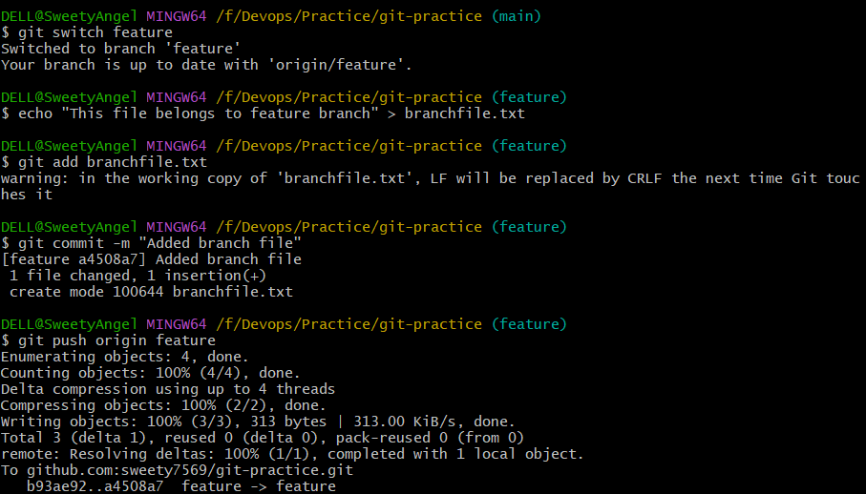
- Clone only a branch from github to local.
Suppose you want to clone only feature.
Use:
git clone -b feature --single-branch https://github.com/USERNAME/git-practice.git
This downloads the selected branch instead of fetching all branches.
Check:
cd git-practice
git branch
You should see:
* feature
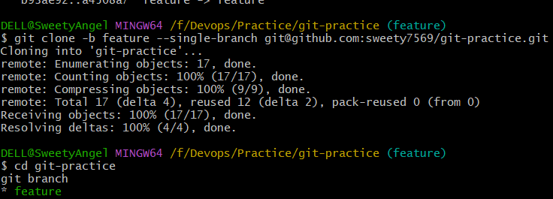
- Create a file with all passwords and make that untrackable with git.
Create a file:
touch passwords.txt
Add some dummy data for practice:
username=admin
password=123456
Initially Git sees it:
git status
Now edit .gitignore:
nano .gitignore
Add:
passwords.txt
Save it.
Check:
git status
passwords.txt should no longer appear as an untracked file.
If the file was already tracked
.gitignore does not stop tracking an already tracked file.
Use:
git rm --cached passwords.txt
Then:
git commit -m "Stop tracking passwords file"
Now Git will ignore it.
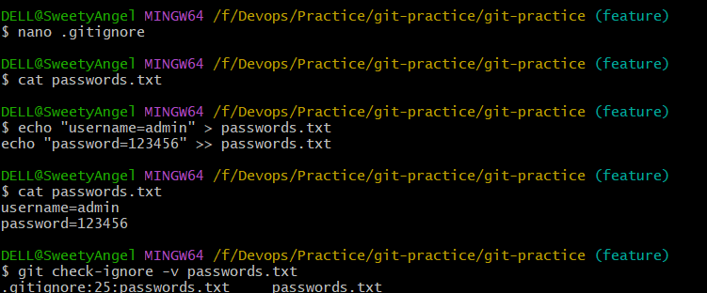
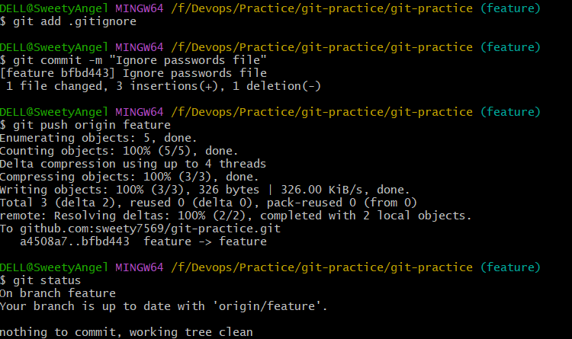

- Make a commit and make that commit reset without savings changes.
Objective
To remove the latest commit and discard its changes using git reset --hard.
Steps
Step 1: Create a file.
echo "Temporary data" > temp.txt
Step 2: Add the file.
git add temp.txt
Step 3: Commit the file.
git commit -m "Added temporary file"
Step 4: Check the commit history.
git log --oneline
Step 5: Reset the latest commit.
git reset --hard HEAD~1
Step 6: Check the log again.
git log --oneline
Step 7: Check the status.
git status
Result
The latest commit and its changes are discarded from the current branch.
Important
git reset --hard can permanently discard uncommitted changes. Use it carefully.

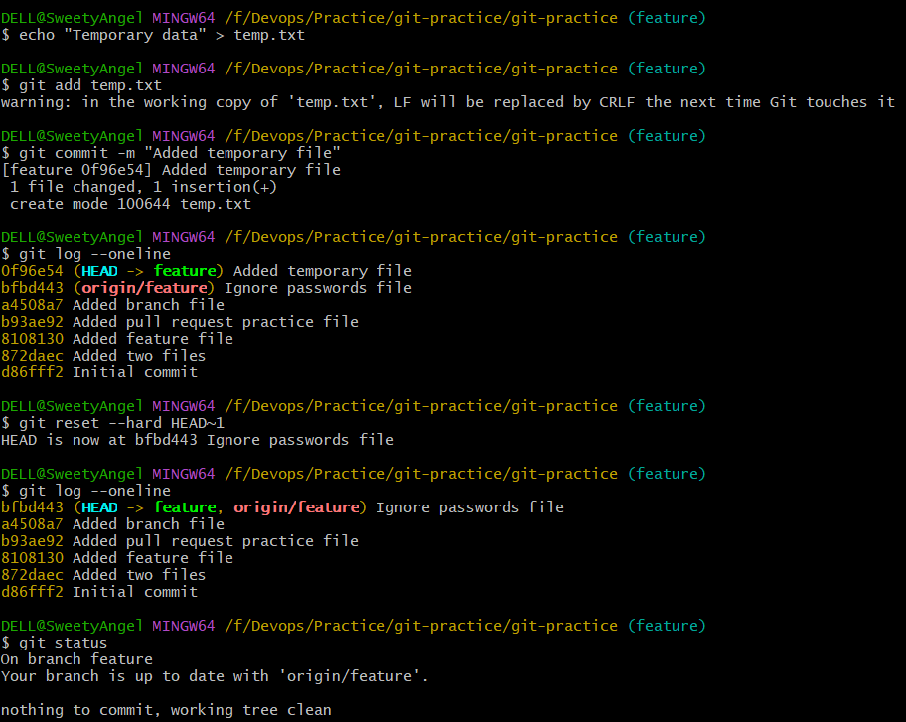

- Revert a commited commit to the older version.
reset and revert are different.
Find the commit:
git log --oneline
Example:
abc1234 Added new feature
def5678 Added old feature
To reverse abc1234:
git revert abc1234
Git creates a new commit that reverses the changes.
Then:
git push origin main
Remember
reset → moves/removes commits from branch history
revert → creates a new commit that undoes an earlier commit
For shared repositories, git revert is generally safer.
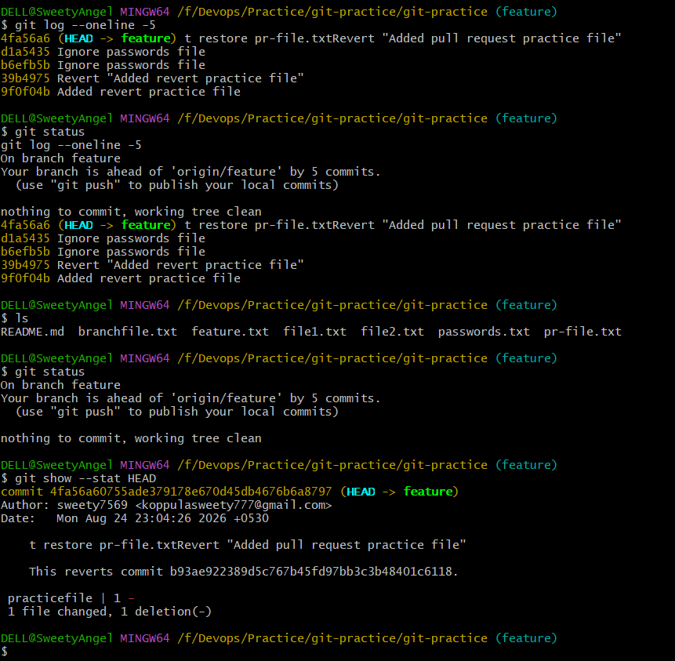

- Push a file to stash without savings the changes and work on another file.
Objective
To temporarily save uncommitted changes using Git stash and work on another file.
Steps
Step 1: Create or modify a file.
echo "New changes" >> fileA.txt
Step 2: Check the status.
git status
Step 3: Stash the changes.
git stash
Step 4: Check the status.
git status
The working directory should be clean.
Step 5: Check the stash.
git stash list
Example:
stash@{0}: WIP on main
Step 6: Create or modify another file.
echo "Work on another file" > fileB.txt
Step 7: Add the file.
git add fileB.txt
Step 8: Commit the file.
git commit -m "Added file B"
Result
The changes in fileA.txt are safely stored in the stash while work continues on fileB.txt.
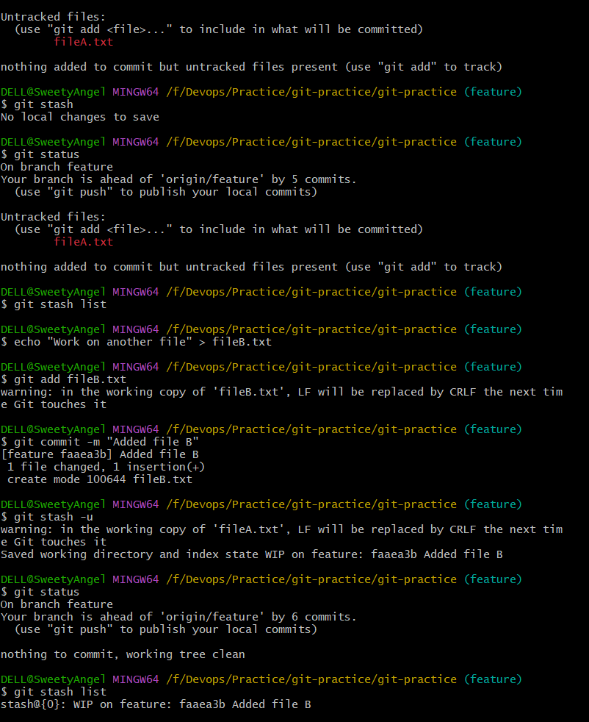

- Undo the stash file and start working on that again.
Check available stashes:
git stash list
Example:
stash@{0}: WIP on main
Restore the latest stash:
git stash pop
Now your changes to fileA.txt come back.
Check:
git status
You can continue working on it.
Difference
git stash pop
Restores and removes the stash.
git stash apply
Restores but keeps the stash.
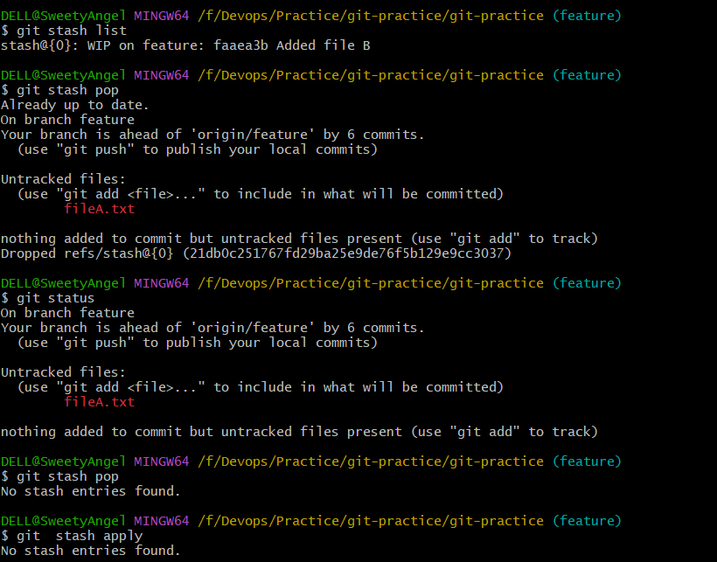

- Generate a ssh-keygen and configure into github.
Check whether you already have SSH keys:
ls ~/.ssh
Generate an ED25519 key:
ssh-keygen -t ed25519 -C "your-email@example.com"
Press Enter to accept the default location.
Start SSH agent:
eval "$(ssh-agent -s)"
Add your key:
ssh-add ~/.ssh/id_ed25519
Display your public key:
cat ~/.ssh/id_ed25519.pub
Copy the entire public key.
⚠️ Never share:
id_ed25519
That is your private key.
Only share:
id_ed25519.pub
In GitHub:
Settings → SSH and GPG keys → New SSH key
Paste the public key.
Test:
ssh -T git@github.com
You should receive a successful authentication message.
Then you can use an SSH remote such as:
git remote set-url origin git@github.com:USERNAME/git-practice.git
Check:
git remote -v
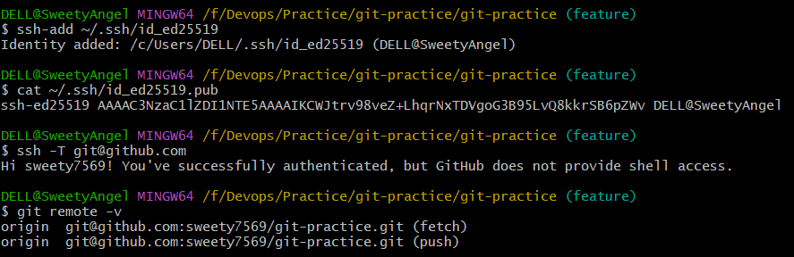

- Configure webhooks to github.
Step 1: Open your GitHub repository
Go to your git-practice repository on GitHub.
Then:
Settings → Webhooks → Add webhook
You should see fields such as:
- Payload URL
- Content type
- Secret
- Which events would you like to trigger this webhook?
- Active
Step 2: Get a webhook URL
Open:
Webhook.site
It will automatically give you a unique URL similar to:
https://webhook.site/xxxxxxxx-xxxx-xxxx-xxxx-xxxxxxxxxxxx
Keep that page open. It will show the requests GitHub sends.
Step 3: Configure GitHub
In GitHub:
Settings → Webhooks → Add webhook
For Payload URL, paste your Webhook.site URL.
For Content type, select:
application/json
For Secret, you can leave it empty for this practice task.
For Which events would you like to trigger this webhook?, select:
Just the push event
Make sure:
☑ Active
Then click:
Add webhook
Step 4: Test the webhook
Go back to your Git Bash repository.
You're currently working on:
/f/Devops/Practice/git-practice/git-practice
Create a small test change:
echo "Webhook test" > webhook-test.txt
Then:
git add webhook-test.txt
Commit:
git commit -m "Test GitHub webhook"
Push:
git push origin feature
Step 5: Check Webhook.site
Go back to the Webhook.site browser tab.
You should see a new request from GitHub.
Click the request and you should be able to see information such as:
Event: push
Repository: git-practice
Branch: feature
Commit information
That proves:
Git push
↓
GitHub
↓
Webhook
↓
Webhook.site
Step 6: Verify from GitHub
Go back to:
GitHub → Settings → Webhooks
Click your webhook.
You should see Recent Deliveries.
A successful delivery should show a successful HTTP response, typically:
200
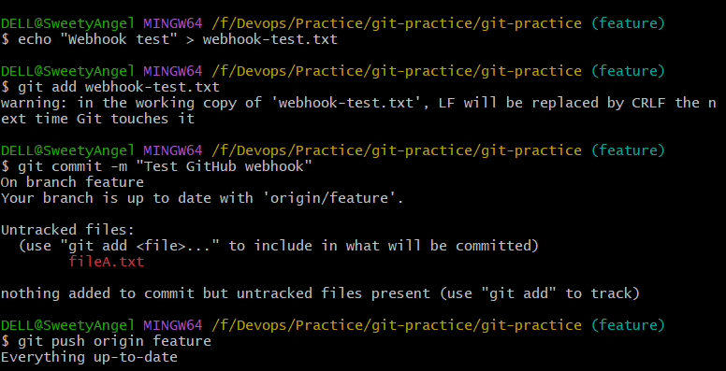
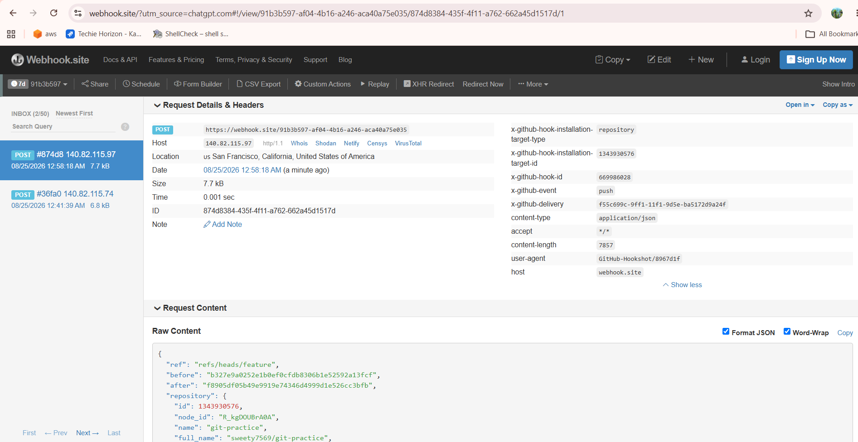

- Basic understanding of .git file.
- .git is a hidden directory created when we run git init or clone a Git repository.
- It contains all the Git metadata and configuration for the repository.
- It stores information about commits, branches, HEAD, and repository history.
- The .git directory tells Git that the current directory is a Git repository.
- We can check it using:
  - ls -la
- We can see the .git directory:
  - .git
  - README.md
  - file1.txt
- Important files/directories inside .git include:
- HEAD – points to the current branch.
- config – contains repository-specific Git configuration.
- objects – stores Git objects such as commits and file contents.
- refs – stores references to branches and tags.
- index – stores information about files staged for commit.
- Do not manually delete or modify .git, because it can damage the repository.
- If .git is removed, the files remain, but Git no longer treats the directory as a Git repository.

- Check all the logs of git.
To view the complete commit history of the repository:
git log
This displays:
- Commit ID (SHA)
- Author
- Date
- Commit message
For a shorter, one-line view:
git log --oneline
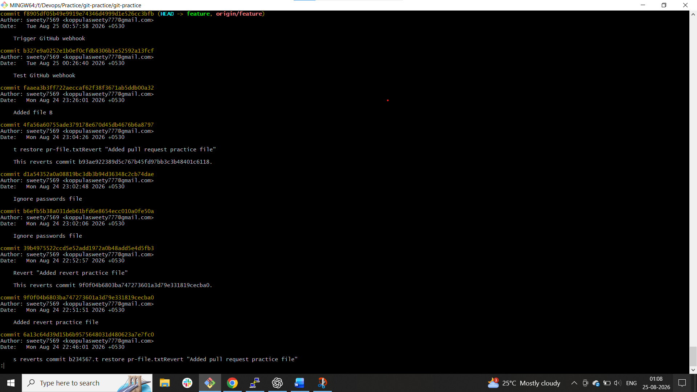

- Rename the commit message.
To rename the latest commit message, use:
git commit --amend -m "New commit message"
You can rename it to:
git commit --amend -m "Updated temporary file"
Then check the updated commit:
git log --oneline -1
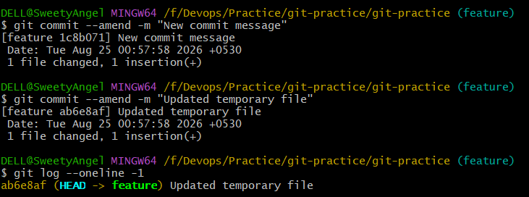

- Merge multiple commits into single commit.
o combine multiple commits into one commit using interactive rebase.
This process is also called squashing commits.
Example
Suppose the history is:
Commit 3
Commit 2
Commit 1
We want:
Single Combined Commit
Steps
Step 1: Check the commit history.
git log --oneline
Step 2: Suppose you want to combine the last three commits.
git rebase -i HEAD~3
Step 3: Git opens an editor containing something similar to:
pick abc123 Commit 1
pick def456 Commit 2
pick ghi789 Commit 3
Step 4: Change it to:
pick abc123 Commit 1
squash def456 Commit 2
squash ghi789 Commit 3
Step 5: Save and close the editor.
Step 6: Git will ask you to create the final commit message.
Enter:
Combined three commits
Step 7: Save and close.
Step 8: Check the history.
git log --oneline
You should now see the commits combined into one.
If the branch was already pushed
You may need:
git push --force-with-lease
Again, avoid rewriting history on shared branches unless necessary.

